**Министерство науки и высшего образования Российской Федерации**

Федеральное государственное автономное образовательное учреждение

высшего профессионального образования

**«НАЦИОНАЛЬНЫЙ ИССЛЕДОВАТЕЛЬСКИЙ**

**ТОМСКИЙ ПОЛИТЕХНИЧЕСКИЙ УНИВЕРСИТЕТ»**

Наименование школы: ИШИТР

Наименование отделения: ОИТ

Наименование направления: Программная инженерия

**Индивидуальное домашнее задание**

**по дисциплине: «Современные концепции организации баз данных»**

Выполнил: студент гр. 8ПМ21 _______ Емельянов А. С.

(Подпись) (Ф.И.О.)

Проверил: ассистент ОИТ ИШИТР _________ Мокина Е. Е.

(Подпись) (Ф.И.О.)

Томск – 2022

Оглавление

Цель работы3

Логическая и реляционная модели3

DDL - код4

DML - код19

Индексация26

Добавление автоинкримента29

Представление палаты и пациента34

Представление доктора и отделения34

**Цель работы**

1. Выбрать предметную область.

2. Создать модель в Oracle Data Modeler (логическую и реляционную модели).

3. Создать базу данных и заполнить данными.

4. Создать дополнительные объекта базы данных.

5. Создать отчёт по ИДЗ, который включает:

* модели, указанные выше;
* код DDL;
* код DML для вставки данных;
* уникальные индексы на все таблицы, в которых первичным ключом является “id”;
* триггеры и сиквенсы для формирования первичного ключа “id” для всех таблиц;
* 2 представления более чем из 2 таблиц.

**Логическая и реляционная модели**

На рисунке 1 представлена логическая модель в Oracle Data Modeler.

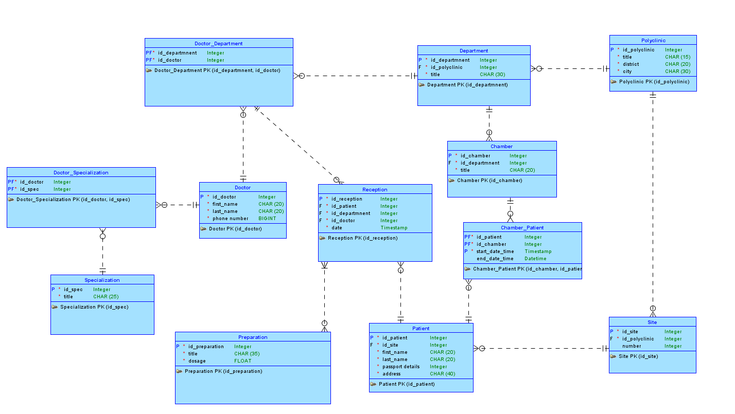

Рисунок 1 - Логическая модель

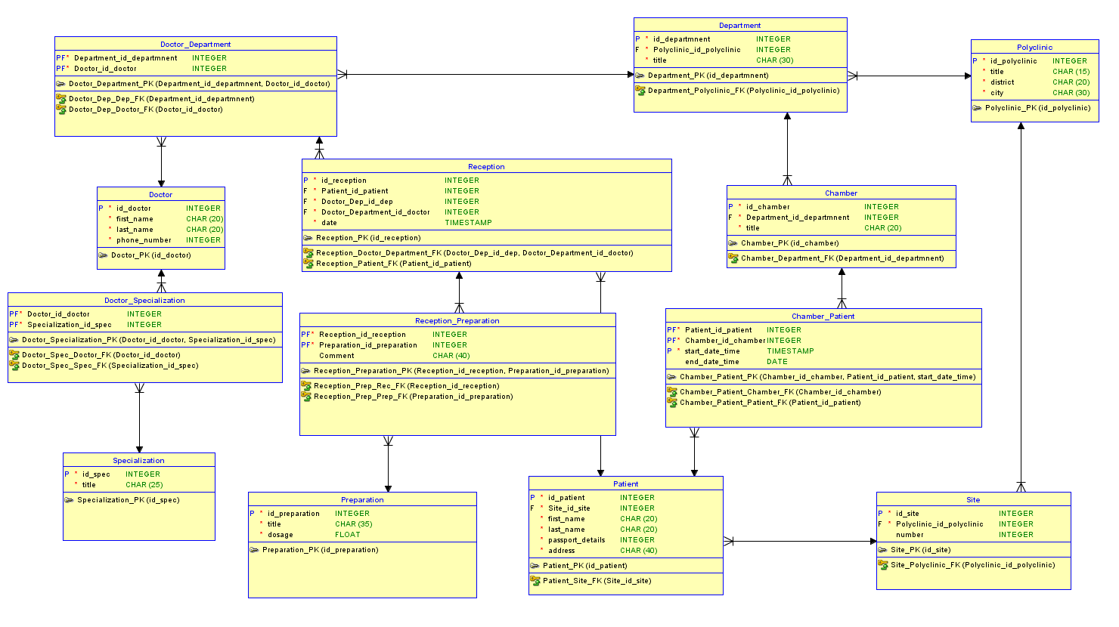

Рисунок 2 - Реляционная модель

**DDL – код**

SET SQL_MODE = "NO_AUTO_VALUE_ON_ZERO";

START TRANSACTION;

SET time_zone = "+00:00";

/*!40101 SET @OLD_CHARACTER_SET_CLIENT=@@CHARACTER_SET_CLIENT */;

/*!40101 SET @OLD_CHARACTER_SET_RESULTS=@@CHARACTER_SET_RESULTS */;

/*!40101 SET @OLD_COLLATION_CONNECTION=@@COLLATION_CONNECTION */;

/*!40101 SET NAMES utf8mb4 */;

--

-- Database: `idz`

--

--

-- Table structure for table `chamber`

--

CREATE TABLE `chamber` (

`id_chamber` int(11) NOT NULL,

`department_id_departmnent` int(11) NOT NULL,

`title` char(20) NOT NULL

) ENGINE=InnoDB DEFAULT CHARSET=utf8mb4 COLLATE=utf8mb4_general_ci;

--

-- Triggers `chamber`

--

DELIMITER $$

CREATE TRIGGER `id_chamber_ai` BEFORE INSERT ON `chamber` FOR EACH ROW BEGIN

SET

NEW.id_chamber =

IF (ISNULL ((SELECT id_chamber FROM chamber ORDER BY id_chamber DESC LIMIT 0, 1)), 1,

(SELECT id_chamber FROM chamber ORDER BY id_chamber DESC LIMIT 0, 1) + 1);

END

$$

DELIMITER ;

--

-- Table structure for table `chamber_patient`

--

CREATE TABLE `chamber_patient` (

`patient_id_patient` int(11) NOT NULL,

`chamber_id_chamber` int(11) NOT NULL,

`start_date_time` timestamp NOT NULL DEFAULT current_timestamp() ON UPDATE current_timestamp(),

`end_date_time` datetime DEFAULT NULL

) ENGINE=InnoDB DEFAULT CHARSET=utf8mb4 COLLATE=utf8mb4_general_ci;

--

-- Table structure for table `department`

--

CREATE TABLE `department` (

`id_department` int(11) NOT NULL,

`polyclinic_id_polyclinic` int(11) NOT NULL,

`title` char(30) NOT NULL

) ENGINE=InnoDB DEFAULT CHARSET=utf8mb4 COLLATE=utf8mb4_general_ci;

--

-- Triggers `department`

--

DELIMITER $$

CREATE TRIGGER `id_department_ai` BEFORE INSERT ON `department` FOR EACH ROW BEGIN

SET

NEW.id_department =

IF (ISNULL ((SELECT id_department FROM department ORDER BY id_department DESC LIMIT 0, 1)), 1,

(SELECT id_department FROM department ORDER BY id_department DESC LIMIT 0, 1) + 1);

END

$$

DELIMITER ;

--

-- Table structure for table `doctor`

--

CREATE TABLE `doctor` (

`id_doctor` int(11) NOT NULL,

`first_name` char(20) NOT NULL,

`last_name` char(20) NOT NULL,

`phone_number` int(11) NOT NULL

) ENGINE=InnoDB DEFAULT CHARSET=utf8mb4 COLLATE=utf8mb4_general_ci;

--

-- Triggers `doctor`

--

DELIMITER $$

CREATE TRIGGER `id_doctor_ai` BEFORE INSERT ON `doctor` FOR EACH ROW BEGIN

SET

NEW.id_doctor =

IF (ISNULL ((SELECT id_doctor FROM doctor ORDER BY id_doctor DESC LIMIT 0, 1)), 1,

(SELECT id_doctor FROM doctor ORDER BY id_doctor DESC LIMIT 0, 1) + 1);

END

$$

DELIMITER ;

--

-- Table structure for table `doctor_department`

--

CREATE TABLE `doctor_department` (

`department_id_departmnent` int(11) NOT NULL,

`doctor_id_doctor` int(11) NOT NULL

) ENGINE=InnoDB DEFAULT CHARSET=utf8mb4 COLLATE=utf8mb4_general_ci;

--

-- Table structure for table `doctor_specialization`

--

CREATE TABLE `doctor_specialization` (

`doctor_id_doctor` int(11) NOT NULL,

`specialization_id_spec` int(11) NOT NULL

) ENGINE=InnoDB DEFAULT CHARSET=utf8mb4 COLLATE=utf8mb4_general_ci;

--

-- Table structure for table `patient`

--

CREATE TABLE `patient` (

`id_patient` int(11) NOT NULL,

`site_id_site` int(11) NOT NULL,

`first_name` char(20) NOT NULL,

`last_name` char(20) NOT NULL,

`passport_details` int(11) NOT NULL,

`address` char(40) NOT NULL

) ENGINE=InnoDB DEFAULT CHARSET=utf8mb4 COLLATE=utf8mb4_general_ci;

--

-- Triggers `patient`

--

DELIMITER $$

CREATE TRIGGER `id_patient_ai` BEFORE INSERT ON `patient` FOR EACH ROW BEGIN

SET

NEW.id_patient =

IF (ISNULL ((SELECT id_patient FROM id_patient ORDER BY id_patient DESC LIMIT 0, 1)), 1,

(SELECT id_patient FROM patient ORDER BY id_patient DESC LIMIT 0, 1) + 1);

END

$$

DELIMITER ;

--

-- Table structure for table `polyclinic`

--

CREATE TABLE `polyclinic` (

`id_polyclinic` int(11) NOT NULL,

`title` char(15) NOT NULL,

`district` char(20) NOT NULL,

`city` char(30) NOT NULL

) ENGINE=InnoDB DEFAULT CHARSET=utf8mb4 COLLATE=utf8mb4_general_ci;

--

-- Triggers `polyclinic`

--

DELIMITER $$

CREATE TRIGGER `id_polyclinic_ai` BEFORE INSERT ON `polyclinic` FOR EACH ROW BEGIN

SET

NEW.id_polyclinic =

IF (ISNULL ((SELECT id_polyclinic FROM polyclinic ORDER BY id_polyclinic DESC LIMIT 0, 1)), 1,

(SELECT id_polyclinic FROM polyclinic ORDER BY id_polyclinic DESC LIMIT 0, 1) + 1);

END

$$

DELIMITER ;

--

-- Table structure for table `preparation`

--

CREATE TABLE `preparation` (

`id_preparation` int(11) NOT NULL,

`title` char(35) NOT NULL,

`dosage` float NOT NULL

) ENGINE=InnoDB DEFAULT CHARSET=utf8mb4 COLLATE=utf8mb4_general_ci;

--

-- Triggers `preparation`

--

DELIMITER $$

CREATE TRIGGER `id_preparation_ai` BEFORE INSERT ON `preparation` FOR EACH ROW BEGIN

SET

NEW.id_preparation =

IF (ISNULL ((SELECT id_preparation FROM preparation ORDER BY id_preparation DESC LIMIT 0, 1)), 1,

(SELECT id_preparation FROM preparation ORDER BY id_preparation DESC LIMIT 0, 1) + 1);

END

$$

DELIMITER ;

--

-- Table structure for table `reception`

--

CREATE TABLE `reception` (

`id_reception` int(11) NOT NULL,

`patient_id_patient` int(11) NOT NULL,

`doctor_dep_id_dep` int(11) NOT NULL,

`doctor_department_id_doctor` int(11) NOT NULL,

`date` timestamp NOT NULL DEFAULT current_timestamp() ON UPDATE current_timestamp()

) ENGINE=InnoDB DEFAULT CHARSET=utf8mb4 COLLATE=utf8mb4_general_ci;

--

-- Triggers `reception`

--

DELIMITER $$

CREATE TRIGGER `id_reception_ai` BEFORE INSERT ON `reception` FOR EACH ROW BEGIN

SET

NEW.id_reception =

IF (ISNULL ((SELECT id_reception FROM reception ORDER BY id_reception DESC LIMIT 0, 1)), 1,

(SELECT id_reception FROM reception ORDER BY id_reception DESC LIMIT 0, 1) + 1);

END

$$

DELIMITER ;

--

-- Table structure for table `reception_preparation`

--

CREATE TABLE `reception_preparation` (

`reception_id_reception` int(11) NOT NULL,

`preparation_id_preparation` int(11) NOT NULL,

`Comment` char(40) DEFAULT NULL

) ENGINE=InnoDB DEFAULT CHARSET=utf8mb4 COLLATE=utf8mb4_general_ci;

--

-- Table structure for table `site`

--

CREATE TABLE `site` (

`id_site` int(11) NOT NULL,

`polyclinic_id_polyclinic` int(11) NOT NULL,

`number` int(11) DEFAULT NULL

) ENGINE=InnoDB DEFAULT CHARSET=utf8mb4 COLLATE=utf8mb4_general_ci;

--

-- Triggers `site`

--

DELIMITER $$

CREATE TRIGGER `id_site_ai` BEFORE INSERT ON `site` FOR EACH ROW BEGIN

SET

NEW.id_site =

IF (ISNULL ((SELECT id_site FROM site ORDER BY id_site DESC LIMIT 0, 1)), 1,

(SELECT id_site FROM site ORDER BY id_site DESC LIMIT 0, 1) + 1);

END

$$

DELIMITER ;

--

-- Table structure for table `specialization`

--

CREATE TABLE `specialization` (

`id_spec` int(11) NOT NULL,

`title` char(25) NOT NULL

) ENGINE=InnoDB DEFAULT CHARSET=utf8mb4 COLLATE=utf8mb4_general_ci;

--

-- Triggers `specialization`

--

DELIMITER $$

CREATE TRIGGER `id_specialization_ai` BEFORE INSERT ON `specialization` FOR EACH ROW BEGIN

SET

NEW.id_spec =

IF (ISNULL ((SELECT id_spec FROM spec ORDER BY id_spec DESC LIMIT 0, 1)), 1,

(SELECT ispec FROM spec ORDER BY id_spec DESC LIMIT 0, 1) + 1);

END

$$

DELIMITER ;

--

-- Indexes for dumped tables

--

--

-- Indexes for table `chamber`

--

ALTER TABLE `chamber`

ADD PRIMARY KEY (`id_chamber`),

ADD KEY `chamber_department_fk` (`department_id_departmnent`);

--

-- Indexes for table `chamber_patient`

--

ALTER TABLE `chamber_patient`

ADD PRIMARY KEY (`chamber_id_chamber`,`patient_id_patient`,`start_date_time`),

ADD KEY `chamber_patient_patient_fk` (`patient_id_patient`);

--

-- Indexes for table `department`

--

ALTER TABLE `department`

ADD PRIMARY KEY (`id_department`),

ADD KEY `department_polyclinic_fk` (`polyclinic_id_polyclinic`);

--

-- Indexes for table `doctor`

--

ALTER TABLE `doctor`

ADD PRIMARY KEY (`id_doctor`);

--

-- Indexes for table `doctor_department`

--

ALTER TABLE `doctor_department`

ADD PRIMARY KEY (`department_id_departmnent`,`doctor_id_doctor`),

ADD KEY `doctor_dep_doctor_fk` (`doctor_id_doctor`);

--

-- Indexes for table `doctor_specialization`

--

ALTER TABLE `doctor_specialization`

ADD PRIMARY KEY (`doctor_id_doctor`,`specialization_id_spec`),

ADD KEY `doctor_spec_spec_fk` (`specialization_id_spec`);

--

-- Indexes for table `patient`

--

ALTER TABLE `patient`

ADD PRIMARY KEY (`id_patient`),

ADD KEY `patient_site_fk` (`site_id_site`);

--

-- Indexes for table `polyclinic`

--

ALTER TABLE `polyclinic`

ADD PRIMARY KEY (`id_polyclinic`);

--

-- Indexes for table `preparation`

--

ALTER TABLE `preparation`

ADD PRIMARY KEY (`id_preparation`);

--

-- Indexes for table `reception`

--

ALTER TABLE `reception`

ADD PRIMARY KEY (`id_reception`),

ADD KEY `reception_doctor_department_fk` (`doctor_dep_id_dep`,`doctor_department_id_doctor`),

ADD KEY `reception_patient_fk` (`patient_id_patient`);

--

-- Indexes for table `reception_preparation`

--

ALTER TABLE `reception_preparation`

ADD PRIMARY KEY (`reception_id_reception`,`preparation_id_preparation`),

ADD KEY `reception_prep_prep_fk` (`preparation_id_preparation`);

--

-- Indexes for table `site`

--

ALTER TABLE `site`

ADD PRIMARY KEY (`id_site`),

ADD KEY `site_polyclinic_fk` (`polyclinic_id_polyclinic`);

--

-- Indexes for table `specialization`

--

ALTER TABLE `specialization`

ADD PRIMARY KEY (`id_spec`);

--

-- Constraints for dumped tables

--

--

-- Constraints for table `chamber`

--

ALTER TABLE `chamber`

ADD CONSTRAINT `chamber_department_fk` FOREIGN KEY (`department_id_departmnent`) REFERENCES `department` (`id_department`);

--

-- Constraints for table `chamber_patient`

--

ALTER TABLE `chamber_patient`

ADD CONSTRAINT `chamber_patient_chamber_fk` FOREIGN KEY (`chamber_id_chamber`) REFERENCES `chamber` (`id_chamber`),

ADD CONSTRAINT `chamber_patient_patient_fk` FOREIGN KEY (`patient_id_patient`) REFERENCES `patient` (`id_patient`);

--

-- Constraints for table `department`

--

ALTER TABLE `department`

ADD CONSTRAINT `department_polyclinic_fk` FOREIGN KEY (`polyclinic_id_polyclinic`) REFERENCES `polyclinic` (`id_polyclinic`);

--

-- Constraints for table `doctor_department`

--

ALTER TABLE `doctor_department`

ADD CONSTRAINT `doctor_dep_dep_fk` FOREIGN KEY (`department_id_departmnent`) REFERENCES `department` (`id_department`),

ADD CONSTRAINT `doctor_dep_doctor_fk` FOREIGN KEY (`doctor_id_doctor`) REFERENCES `doctor` (`id_doctor`);

--

-- Constraints for table `doctor_specialization`

--

ALTER TABLE `doctor_specialization`

ADD CONSTRAINT `doctor_spec_doctor_fk` FOREIGN KEY (`doctor_id_doctor`) REFERENCES `doctor` (`id_doctor`),

ADD CONSTRAINT `doctor_spec_spec_fk` FOREIGN KEY (`specialization_id_spec`) REFERENCES `specialization` (`id_spec`);

--

-- Constraints for table `patient`

--

ALTER TABLE `patient`

ADD CONSTRAINT `patient_site_fk` FOREIGN KEY (`site_id_site`) REFERENCES `site` (`id_site`);

--

-- Constraints for table `reception`

--

ALTER TABLE `reception`

ADD CONSTRAINT `reception_doctor_department_fk` FOREIGN KEY (`doctor_dep_id_dep`,`doctor_department_id_doctor`) REFERENCES `doctor_department` (`department_id_departmnent`, `doctor_id_doctor`),

ADD CONSTRAINT `reception_patient_fk` FOREIGN KEY (`patient_id_patient`) REFERENCES `patient` (`id_patient`);

--

-- Constraints for table `reception_preparation`

--

ALTER TABLE `reception_preparation`

ADD CONSTRAINT `reception_prep_prep_fk` FOREIGN KEY (`preparation_id_preparation`) REFERENCES `preparation` (`id_preparation`),

ADD CONSTRAINT `reception_prep_rec_fk` FOREIGN KEY (`reception_id_reception`) REFERENCES `reception` (`id_reception`);

--

-- Constraints for table `site`

--

ALTER TABLE `site`

ADD CONSTRAINT `site_polyclinic_fk` FOREIGN KEY (`polyclinic_id_polyclinic`) REFERENCES `polyclinic` (`id_polyclinic`);

COMMIT;

**DML – код**

SET SQL_MODE = "NO_AUTO_VALUE_ON_ZERO";

START TRANSACTION;

SET time_zone = "+00:00";

/*!40101 SET @OLD_CHARACTER_SET_CLIENT=@@CHARACTER_SET_CLIENT */;

/*!40101 SET @OLD_CHARACTER_SET_RESULTS=@@CHARACTER_SET_RESULTS */;

/*!40101 SET @OLD_COLLATION_CONNECTION=@@COLLATION_CONNECTION */;

/*!40101 SET NAMES utf8mb4 */;

--

-- Database: `idz`

--

--

-- Dumping data for table `chamber`

--

INSERT INTO `chamber` (`id_chamber`, `department_id_departmnent`, `title`) VALUES

(23743390, 7843278, 'Бюджет'),

(23744590, 6843279, 'Комфорт'),

(23748187, 6843280, 'Бюджет'),

(23748290, 7843280, 'Комфорт'),

(23748292, 6843279, 'Бюджет'),

(23748397, 6843281, 'Бюджет'),

(23748453, 6843282, 'Комфорт'),

(23748476, 7843281, 'Комфорт'),

(23748554, 7843282, 'Бюджет'),

(23765290, 6843278, 'Комфорт');

--

-- Dumping data for table `chamber_patient`

--

INSERT INTO `chamber_patient` (`patient_id_patient`, `chamber_id_chamber`, `start_date_time`, `end_date_time`) VALUES

(623483, 23743390, '2022-12-22 22:26:38', '2022-12-24 05:26:29'),

(905944, 23744590, '2022-12-22 22:28:07', '2023-12-14 05:26:48'),

(268947, 23748187, '2022-12-22 22:28:07', '2023-12-05 05:26:48'),

(123483, 23748290, '2022-12-22 22:28:07', '2022-12-29 05:26:48'),

(238944, 23748292, '2022-12-22 22:28:07', '2022-12-27 05:26:48'),

(256947, 23748397, '2022-12-22 22:28:07', '2025-01-16 05:26:48'),

(739947, 23748453, '2022-12-22 22:28:07', '2023-02-09 05:26:48'),

(238947, 23748476, '2022-12-22 22:28:07', '2023-02-16 05:26:48'),

(239947, 23748554, '2022-12-22 22:28:07', '2023-04-19 05:26:48'),

(738947, 23765290, '2022-12-22 22:28:07', '2023-03-16 05:26:48');

--

-- Dumping data for table `department`

--

INSERT INTO `department` (`id_department`, `polyclinic_id_polyclinic`, `title`) VALUES

(6843278, 546470, 'Хирургия'),

(6843279, 546464, 'Терапевтия'),

(6843280, 546456, 'Отоларингология'),

(6843281, 546468, 'Офтальмология'),

(6843282, 546457, 'Неврология'),

(7843278, 546470, 'Хирургия'),

(7843279, 546464, 'Терапевтия'),

(7843280, 546456, 'Отоларингология'),

(7843281, 546468, 'Офтальмология'),

(7843282, 546457, 'Неврология');

--

-- Dumping data for table `doctor`

--

INSERT INTO `doctor` (`id_doctor`, `first_name`, `last_name`, `phone_number`) VALUES

(53675, 'Александр', 'Дзидзария', 999379893),

(53676, 'Андрей', 'Емельянов', 999379894),

(53677, 'Сергей', 'Савельев', 999379895),

(53678, 'Семён', 'Тереньтьев', 999379896),

(53679, 'Пётр', 'Иванов', 999379897);

--

-- Dumping data for table `doctor_department`

--

INSERT INTO `doctor_department` (`department_id_departmnent`, `doctor_id_doctor`) VALUES

(6843278, 53677),

(6843279, 53676),

(6843280, 53675),

(6843281, 53679),

(6843282, 53675),

(7843278, 53678),

(7843279, 53679),

(7843280, 53676),

(7843281, 53678),

(7843282, 53677);

--

-- Dumping data for table `doctor_specialization`

--

INSERT INTO `doctor_specialization` (`doctor_id_doctor`, `specialization_id_spec`) VALUES

(53675, 8478354),

(53675, 8478357),

(53676, 8478354),

(53676, 8478359),

(53677, 8374674),

(53677, 8478357),

(53677, 8478394),

(53678, 8374674),

(53678, 8478354),

(53679, 8478394);

--

-- Dumping data for table `patient`

--

INSERT INTO `patient` (`id_patient`, `site_id_site`, `first_name`, `last_name`, `passport_details`, `address`) VALUES

(123483, 34342, 'Камила', 'Серпухова', 128373178, 'улица Костромская'),

(238944, 92446, 'Людмила', 'Солнцева', 128373878, 'улица Новая Москва'),

(238947, 92445, 'Екатерина', 'Кальева', 128373179, 'проспект Старый'),

(239947, 54512, 'Григорий', 'Шпак', 128373378, 'проспект Сергия'),

(256947, 92445, 'Екатерина', 'Кальева', 128373179, 'проспект Старый'),

(268947, 84342, 'Светлана', 'Кабалова', 128373478, 'улица Рассветная'),

(623483, 34342, 'Камила', 'Серпухова', 128373178, 'улица Костромская'),

(738947, 84342, 'Светлана', 'Кабалова', 128373478, 'улица Рассветная'),

(739947, 54512, 'Григорий', 'Шпак', 128373378, 'проспект Сергия'),

(905944, 92446, 'Людмила', 'Солнцева', 128373878, 'улица Новая Москва');

--

-- Dumping data for table `polyclinic`

--

INSERT INTO `polyclinic` (`id_polyclinic`, `title`, `district`, `city`) VALUES

(546456, 'Детская', 'Советский', 'Новосибирск'),

(546457, 'Томлад', 'Центральный', 'Москва'),

(546464, 'Взрослая', 'Кировский', 'Томск'),

(546468, 'Добрышевская', 'Октябрьский', 'Омск'),

(546470, 'Областная', 'Ленинский', 'Казань');

--

-- Dumping data for table `preparation`

--

INSERT INTO `preparation` (`id_preparation`, `title`, `dosage`) VALUES

(754382, 'Мирамистин', 75),

(754384, 'Сироп солодки', 90),

(754387, 'Цитрамон', 10),

(848323, 'Авамикс', 80),

(848329, 'Кардионат', 100);

--

-- Dumping data for table `reception`

--

INSERT INTO `reception` (`id_reception`, `patient_id_patient`, `doctor_dep_id_dep`, `doctor_department_id_doctor`, `date`) VALUES

(124, 738947, 7843278, 53678, '2022-12-22 23:20:20'),

(134, 238944, 7843281, 53678, '2022-12-22 23:20:20'),

(234, 739947, 6843282, 53675, '2022-12-22 23:20:20'),

(265, 623483, 7843280, 53676, '2022-12-22 23:20:20'),co

(345, 268947, 6843281, 53679, '2022-12-22 23:20:20'),

(432, 238947, 7843279, 53679, '2022-12-22 23:20:20'),

(567, 238947, 6843280, 53675, '2022-12-22 23:20:20'),

(669, 623483, 6843278, 53677, '2022-12-22 23:16:42'),

(759, 239947, 6843279, 53676, '2022-12-22 23:20:20'),

(789, 905944, 7843282, 53677, '2022-12-22 23:20:20');

--

-- Dumping data for table `reception_preparation`

--

INSERT INTO `reception_preparation` (`reception_id_reception`, `preparation_id_preparation`, `Comment`) VALUES

(124, 754382, 'Принимать натощак'),

(265, 848329, 'По 2 таблетки в день'),

(567, 754384, 'Запивать вместе с едой'),

(759, 848323, 'По 1 дозе в каждый носовой проход'),

(789, 754387, 'Не принимать с алкоголем');

--

-- Dumping data for table `site`

--

INSERT INTO `site` (`id_site`, `polyclinic_id_polyclinic`, `number`) VALUES

(14512, 546456, 3),

(27782, 546464, 2),

(32445, 546468, 4),

(34342, 546457, 5),

(36723, 546470, 1),

(46723, 546470, 1),

(54512, 546456, 3),

(84342, 546457, 5),

(92445, 546468, 4),

(92446, 546457, 7);

--

-- Dumping data for table `specialization`

--

INSERT INTO `specialization` (`id_spec`, `title`) VALUES

(8374674, 'Хирург'),

(8478354, 'Терапевт'),

(8478357, 'Невролог'),

(8478359, 'Отоларинголог'),

(8478394, 'Офтальмолог');

COMMIT;

/*!40101 SET CHARACTER_SET_CLIENT=@OLD_CHARACTER_SET_CLIENT */;

/*!40101 SET CHARACTER_SET_RESULTS=@OLD_CHARACTER_SET_RESULTS */;

/*!40101 SET COLLATION_CONNECTION=@OLD_COLLATION_CONNECTION */;

**Индексация**

--

-- Indexes for dumped tables

--

--

-- Indexes for table `chamber`

--

ALTER TABLE `chamber`

ADD PRIMARY KEY (`id_chamber`),

ADD KEY `chamber_department_fk` (`department_id_departmnent`);

--

-- Indexes for table `chamber_patient`

--

ALTER TABLE `chamber_patient`

ADD PRIMARY KEY (`chamber_id_chamber`,`patient_id_patient`,`start_date_time`),

ADD KEY `chamber_patient_patient_fk` (`patient_id_patient`);

--

-- Indexes for table `department`

--

ALTER TABLE `department`

ADD PRIMARY KEY (`id_department`),

ADD KEY `department_polyclinic_fk` (`polyclinic_id_polyclinic`);

--

-- Indexes for table `doctor`

--

ALTER TABLE `doctor`

ADD PRIMARY KEY (`id_doctor`);

--

-- Indexes for table `doctor_department`

--

ALTER TABLE `doctor_department`

ADD PRIMARY KEY (`department_id_departmnent`,`doctor_id_doctor`),

ADD KEY `doctor_dep_doctor_fk` (`doctor_id_doctor`);

--

-- Indexes for table `doctor_specialization`

--

ALTER TABLE `doctor_specialization`

ADD PRIMARY KEY (`doctor_id_doctor`,`specialization_id_spec`),

ADD KEY `doctor_spec_spec_fk` (`specialization_id_spec`);

--

-- Indexes for table `patient`

--

ALTER TABLE `patient`

ADD PRIMARY KEY (`id_patient`),

ADD KEY `patient_site_fk` (`site_id_site`);

--

-- Indexes for table `polyclinic`

--

ALTER TABLE `polyclinic`

ADD PRIMARY KEY (`id_polyclinic`);

--

-- Indexes for table `preparation`

--

ALTER TABLE `preparation`

ADD PRIMARY KEY (`id_preparation`);

--

-- Indexes for table `reception`

--

ALTER TABLE `reception`

ADD PRIMARY KEY (`id_reception`),

ADD KEY `reception_doctor_department_fk` (`doctor_dep_id_dep`,`doctor_department_id_doctor`),

ADD KEY `reception_patient_fk` (`patient_id_patient`);

--

-- Indexes for table `reception_preparation`

--

ALTER TABLE `reception_preparation`

ADD PRIMARY KEY (`reception_id_reception`,`preparation_id_preparation`),

ADD KEY `reception_prep_prep_fk` (`preparation_id_preparation`);

--

-- Indexes for table `site`

--

ALTER TABLE `site`

ADD PRIMARY KEY (`id_site`),

ADD KEY `site_polyclinic_fk` (`polyclinic_id_polyclinic`);

--

-- Indexes for table `specialization`

--

ALTER TABLE `specialization`

ADD PRIMARY KEY (`id_spec`);

**Добавление автоинкремента**

--

-- Triggers `chamber`

--

DELIMITER $$

CREATE TRIGGER `id_chamber_ai` BEFORE INSERT ON `chamber` FOR EACH ROW BEGIN

SET

NEW.id_chamber =

IF (ISNULL ((SELECT id_chamber FROM chamber ORDER BY id_chamber DESC LIMIT 0, 1)), 1,

(SELECT id_chamber FROM chamber ORDER BY id_chamber DESC LIMIT 0, 1) + 1);

END

$$

DELIMITER ;

--

-- Triggers `department`

--

DELIMITER $$

CREATE TRIGGER `id_department_ai` BEFORE INSERT ON `department` FOR EACH ROW BEGIN

SET

NEW.id_department =

IF (ISNULL ((SELECT id_department FROM department ORDER BY id_department DESC LIMIT 0, 1)), 1,

(SELECT id_department FROM department ORDER BY id_department DESC LIMIT 0, 1) + 1);

END

$$

DELIMITER ;

--

-- Triggers `doctor`

--

DELIMITER $$

CREATE TRIGGER `id_doctor_ai` BEFORE INSERT ON `doctor` FOR EACH ROW BEGIN

SET

NEW.id_doctor =

IF (ISNULL ((SELECT id_doctor FROM doctor ORDER BY id_doctor DESC LIMIT 0, 1)), 1,

(SELECT id_doctor FROM doctor ORDER BY id_doctor DESC LIMIT 0, 1) + 1);

END

$$

DELIMITER ;

--

-- Triggers `patient`

--

DELIMITER $$

CREATE TRIGGER `id_patient_ai` BEFORE INSERT ON `patient` FOR EACH ROW BEGIN

SET

NEW.id_patient =

IF (ISNULL ((SELECT id_patient FROM id_patient ORDER BY id_patient DESC LIMIT 0, 1)), 1,

(SELECT id_patient FROM patient ORDER BY id_patient DESC LIMIT 0, 1) + 1);

END

$$

DELIMITER ;

--

-- Triggers `polyclinic`

--

DELIMITER $$

CREATE TRIGGER `id_polyclinic_ai` BEFORE INSERT ON `polyclinic` FOR EACH ROW BEGIN

SET

NEW.id_polyclinic =

IF (ISNULL ((SELECT id_polyclinic FROM polyclinic ORDER BY id_polyclinic DESC LIMIT 0, 1)), 1,

(SELECT id_polyclinic FROM polyclinic ORDER BY id_polyclinic DESC LIMIT 0, 1) + 1);

END

$$

DELIMITER ;

--

-- Triggers `preparation`

--

DELIMITER $$

CREATE TRIGGER `id_preparation_ai` BEFORE INSERT ON `preparation` FOR EACH ROW BEGIN

SET

NEW.id_preparation =

IF (ISNULL ((SELECT id_preparation FROM preparation ORDER BY id_preparation DESC LIMIT 0, 1)), 1,

(SELECT id_preparation FROM preparation ORDER BY id_preparation DESC LIMIT 0, 1) + 1);

END

$$

DELIMITER ;

--

-- Triggers `reception`

--

DELIMITER $$

CREATE TRIGGER `id_reception_ai` BEFORE INSERT ON `reception` FOR EACH ROW BEGIN

SET

NEW.id_reception =

IF (ISNULL ((SELECT id_reception FROM reception ORDER BY id_reception DESC LIMIT 0, 1)), 1,

(SELECT id_reception FROM reception ORDER BY id_reception DESC LIMIT 0, 1) + 1);

END

$$

DELIMITER ;

--

-- Triggers `site`

--

DELIMITER $$

CREATE TRIGGER `id_site_ai` BEFORE INSERT ON `site` FOR EACH ROW BEGIN

SET

NEW.id_site =

IF (ISNULL ((SELECT id_site FROM site ORDER BY id_site DESC LIMIT 0, 1)), 1,

(SELECT id_site FROM site ORDER BY id_site DESC LIMIT 0, 1) + 1);

END

$$

DELIMITER ;

--

-- Triggers `specialization`

--

DELIMITER $$

CREATE TRIGGER `id_specialization_ai` BEFORE INSERT ON `specialization` FOR EACH ROW BEGIN

SET

NEW.id_spec =

IF (ISNULL ((SELECT id_spec FROM spec ORDER BY id_spec DESC LIMIT 0, 1)), 1,

(SELECT ispec FROM spec ORDER BY id_spec DESC LIMIT 0, 1) + 1);

END

$$

DELIMITER ;

Представление палаты и пациента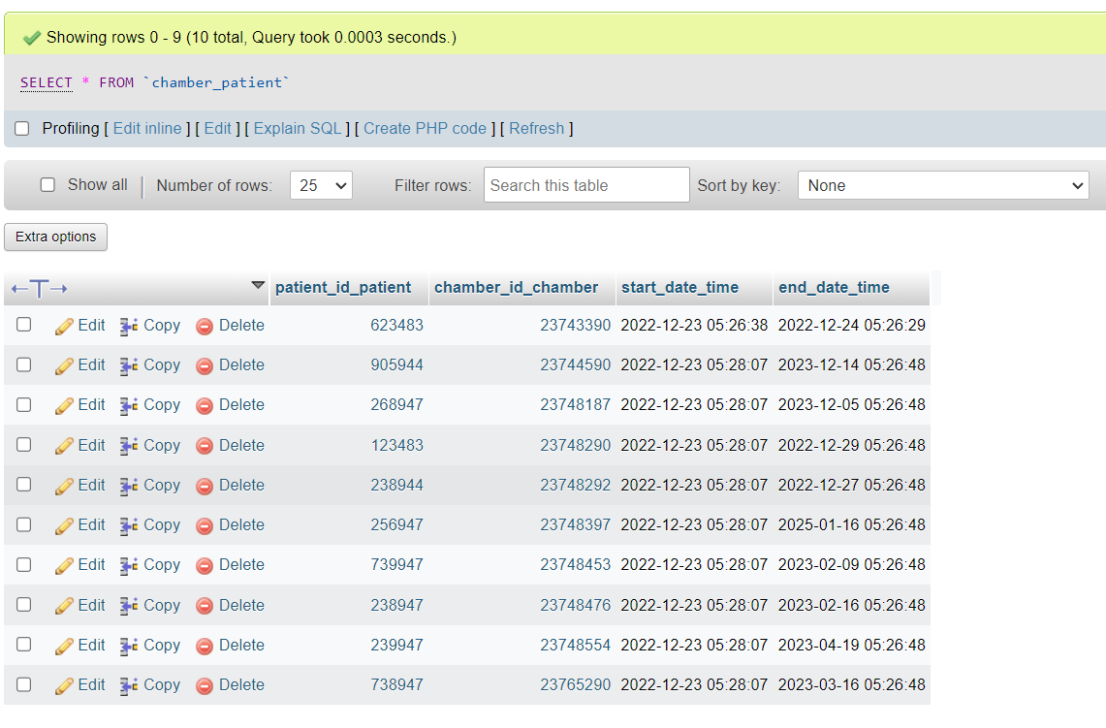

Представление доктора и отделения

